**CROP & WEED DETECTION**

Submitted in partial fulfilments of the requirements of the degree of

BACHELOR OF COMPUTER ENGINEERING

by

**Devansh Jain (19102024)**

**Vighnesh Desai (19102016)**

**Prince Jain (19102020)**

**Viraj Jadhav (19102022)**

Guide

**Prof. Sachin Balwant Takmare**



Department of Computer Engineering

1. P. SHAH INSTITUTE OF TECHNOLOGY, THANE

University of Mumbai

2022-2023

A. P. SHAH INSTITUTE OF TECHNOLOGY, THANE

CERTIFICATE

This is to certify that the project entitled “**Crop and Weed Detection**” is a bonafide work of **Devansh Jain** (19102024), **Vighnesh Desai** (19102016), **Prince Jain** (19102020), **Viraj Jadhav** (19102022)” submitted to the University of Mumbai in partial fulfillment of the requirement for the award of the degree of Bachelor of Engineering in Computer Engineering.

**________________________________ __________________________________**

Guide Project Coordinator

Prof. Sachin B. Takmare Prof. Rushikesh R. Nikam

_______________________ ______________________

Head of Department Principal

Prof. Sachin H. Malave Dr. Uttam D. Kolekar

Date:

A. P. SHAH INSTITUTE OF TECHNOLOGY, THANE

**Project Report Approval for B.E.**

This project report for Sem-VIII entitled **“Crop and Weed Detection”**by **Devansh Jain (19102024), Vighnesh Desai (19102016), Prince Jain (19102020), Viraj Jadhav (19102022)** is approved for the degree of ***Bachelor of Engineering*** in ***Computer Engineering***, ***2022-23***.

Examiner Name Signature

1. ___________________________

2. ___________________________

Date:

Place:

**Declaration**

We declare that this written submission represents my ideas in my own words and where others' ideas or words have been included, I have adequately cited and referenced the original sources. I also declare that I have adhered to all principles of academic honesty and integrity and have not misrepresented or fabricated or falsified any idea/data/fact/source in my submission. I understand that any violation of the above will be the cause for disciplinary action by the Institute and can also invoke penal action from the sources which have thus not been properly cited or from whom proper permission has not been taken when needed.

-----------------------------------------

Devansh Jain (19102024)

-----------------------------------------

Vighnesh Desai (19102016)

-----------------------------------------

Prince Jain (19102020)

-----------------------------------------

Viraj Jadhav (19102022)

Date:

**Abstract**

As the increase in the world population the demand of the sesame crop also increases. Sesame is used as food and flavoring. Sesame is a high oil content crop from which prized oil is extracted. Hence, Sesame plays an important role in the development of a nation’s economy. In order to increase the growth of sesame in the sesame crop it is necessary to detect the weed in the sesame crop and the barren land to minimize the growth of weed so that the growth of the sesame can be increased. A weed is a plant that is considered as unwanted in a particular situation, “a plant in the wrong place”. Weed identification is the identification of weed or undesirable plants from desirable plants in the same field. Various criteria are used for identifying weed from the desired plant. Image processing is one of the technologies used in the same task. Weed identified from images using image processing technique is differentiated by shape, color and size features. These characteristics are used to classify different weeds and crop species. The detection and classification of weeds are of major technical and economic importance in the agricultural industry. Identification of weed and extraction of it increases productivity on feature large scale and therefore leading to better income. Weed identification at the early stage can prevent the desired plants from getting effected. Thus, detection and classification of weeds prove to play an important role in agriculture. Hence, we propose a Deep Learning technique to detect the crop and weed from the input image uploaded by the farmer by using Bounding Boxes, Regions with Convolutional Neural Network(R-CNN) & Support Vector Machine(SVM).

**CONTENTS**

1. Introduction 1
2. Literature Survey 4
3. Limitation of Existing System 9
4. Problem Statement, Objectives and Scope 10

4.1 Problem Statement 10

4.2 Objectives 10

4.3 Scope 10

1. Proposed System 12

5.1 Proposed System Overview 12

5.2 Design details 13

5.3 Methodology 16

1. Experimental Setup 18
2. Results 21
3. Project Plan 26
4. Conclusion 27
5. Future Scope 28

References 29

Publications 31

**LIST OF FIGURES**

5.1 Architecture Diagram 12

5.2.1. Data Flow Diagram (level 0) 13

5.2.1. Data Flow Diagram (level 1) 13

5.2.2 Activity Diagram 14

5.2.3 Sequence Diagram 15

7.1.1 Home Page 21

7.1.2 Home Page 22

7.2 Upload Tab 22

7.3.1 Crop Detection with Multiple Bounding Boxes 23

7.3.2 Crop Detection Results 23

7.4.1 Weed detection with Multiple Bounding Boxes 24

7.4.2 Weed Detection Results 24

7.5 Measures to Remove Weed suggested by Text Message 25

**Abbreviation**

|  |  |
| --- | --- |
| *ML* | Machine Learning |
| *NB* | Naïve Bayes |
| *LR* | Logistic Regression |
| *RF*  *CNN*  *CSS*  *JS*  *HTML* | Random Forest  Convolutional Neural Networks  Cascading Style Sheets  JavaScript  HyperText Markup Language |
|  |  |

**CHAPTER 1**

**Introduction**

During the last centuries, significant progress has taken place in science and technology developments. Significant milestones in diverse areas such as communications, numerical computer control and the miniaturization of components have benefited industrial and productive sectors, providing new means to approach problems in a different manner. The availability of leading-edge technologies has considerably increased, thus becoming more accessible to people. This effect of globalization has allowed many countries to have access to state-of-the-art technological products promoting its application in different areas to generate alternative and more efficient solutions to conventional problems.

Conventional weed control methods are generally cost-ineffective and produce adverse effects on the environment. Hence, there is a need for an automatic weed control system that can reduce human and machinery efforts. Before deploying a weed management system, a precise identification/detection of weeds is a mandatory task. In this regard, computer vision plays a vital role in conjunction with artificial intelligence. Deep learning (DL), a class of machine learning (ML), has been a promising tool for performing various real-life object detection tasks, including agricultural operations, such as identification of plant diseases, agricultural land cover classification, fruit recognition , plant recognition, and many others.

The growths of invasive weeds are hard to control as it grows fast and compete with another crop aggressively. Fungi bacteria and nematodes may be introduced and this is difficult to control and causing the grower to decrease harvest yield and revenue. It is costly to destroy the weed with herbicide and reduce the margin of the cultivator. The fight against weed is part of the daily life of farmers, because it affects their productivity. To achieve this fight, the use of chemical treatments is necessary. The Artificial intelligence, and more precisely Deep Learning, can help to identify or detect precisely the location of this weed, which can help to limit the use of chemical products by treating only the areas concerned.

One of the most daunting challenges is weed control. Weeds are competing with crops for sunlight and water. Cultural practices can minimize infestation, known as suitable irrigation, fertilization and mowing. However, herbicides can offer the maximum effective feed controlling process. Dyrmann, Christiansen has experimented the identification and recognition of weeds under natural field conditions at early growth states remains a research subject with unresolved problems. Depending not only on the growth stage, but also on external factors such as wind, light and nutrition, weed seedlings change appearance, indicating that optimal algorithms for identification and recognition should be able to cope with such changes. Various weed classification strategies have various criteria for the quality of segmentation. If the purpose is to use shape-based features to decide the species to which a plant belongs. In addition, the plant to be included to preserve sharp edges in the segmented image.

Agriculture as one of the oldest branches of science dealing with the cultivation of crops and rearing of animals for both human and industrial consumption has been through different stages of technological development throughout the ages due to man’s quest to reduce human intervention and improve crop yield. The invention of machineries such as tractors, harvesters, planters, sprayers etc. is part of man’s effort towards improving agriculture .Although, these machines have greatly impacted agriculture, but are limited in performing special intelligent functions such as determining ripe fruits or crops to be harvested, selecting the most suitable soil for crops, application of the right quantity of water during irrigation and detection of weeds during weeding process .Weeds are generally found among crops, they compete with other plants for resources such as water, nutrients, air and space thus limiting the growth of desired plants. Improper growth of desired plants will lead to poor crop yield or harvest and in turn have a diminishing effect on the economic status of the farmer.

One of the first approximations for crop detection algorithms was developed in 1996, this algorithm could segment crops from weeds by obtaining a set of infrareds (IR) images. The images were processed by a hysteresis umbral and the Min Neighbouring method to identify the rows of a crop. In recent years the implementation of machine learning has opened new possibilities in weed and crop differentiation process. Recently, the use of Harris Corner detection techniques in CNNs was implemented with the use of Feature Detection, a machine-learning algorithm that uses DBSCAN (Density-based spatial clustering of applications with noise). This algorithm demonstrated an effectiveness of 98% in the identification of weeds in rice crops. Araguez implemented a segmentation algorithm through the analysis of the green histogram of the image of plants and performed the crop and weed segmentation with unspecified classifiers.

The fight against weed remains one of the major challenges in agriculture to improve land productivity. The first and most important step of this fight is to detect and locate this weed. Artificial intelligence has played a very important contribution in this detection. Several applications have been developed using Deep Learning techniques to detect and identify weed, but the variety of weed types complicates this operation. The fight against weed is part of the daily life of farmers, because it affects their productivity. To achieve this fight, the use of chemical treatments is necessary. The Artificial intelligence, and more precisely Deep Learning, can help to identify or detect precisely the location of this weed, which can help to limit the use of chemical products by treating only the areas concerned. A weed is a plant that is considered as unwanted in a particular situation, “a plant in the wrong place”. Weed identification is the identification of weed or undesirable plants from desirable plants in the same field. Various criteria are used for identifying weed from the desired plant. Image processing is one of the technologies used in the same task. Weed identified from images using image processing technique is differentiated by shape, color and size features. These characteristics are used to classify  different weeds and crop species. Weeds are identified also by the probabilistic neural networks.

A site-specific weed management strategy was developed, where density and composition of the weed are taken into consideration. This strategy is precise and uses resources efficiently. However, since farmers dislike to record loss in the overall output of their farm produce and monetary investment, they seek ways to eliminate the presence of weeds and its damaging effect on desired plants through the application of herbicides and other known cultural means . These conventional methods used do not accurately eliminate weeds as they still have a significant level of damaging effect on the desired plants. In order to ensure preciseness and improve accuracy in weed detection; farmers, agricultural organizations, research institutes are now incorporating artificial intelligence principles through various technological devices and gadgets to aid in the process.

This project, Crop and Weed Detection aims at detecting crop and weed from input image provided by the user on web application.

**CHAPTER 2**

**Literature Survey**

The weed and crop may not have differentiating characteristics, and it is exceedingly difficult to separate the weed and crop using a single attribute. It is vital to design techniques that can examine all available differentiating traits. Pattern recognition systems such as Artificial Neural Networks (ANN) and Support Vector Machine (SVM) may integrate numerous such characteristics to differentiate the weed or crop. For weed detection in soybean, neural networks pre-trained with unsupervised K-means feature learning obtained an average efficiency[1].Support Vector Machine (SVM) is a supervised learning approach based on statistical learning theory. SVM was effectively used to distinguish chili and weed from digital photos[2]. Weeds grow in a field in various patterns, such as when a whole portion of the field is covered by the weed, while other times the weed grows in between the crops. Ground-based or remote sensing-based technologies may readily identify weeds in huge weed patches and take necessary action. If the weed grows between the crops, the situation becomes more difficult. In this context, remote sensing technologies are often incapable of identifying weeds. Although ground-based approaches can identify, their accuracy is extremely low. Ground-based solutions, such as attaching a camera to a tractor and scanning the field, can provide adequate findings during the weed's early development stage[3].

One of the most efficient object identification algorithms and one that incorporates many of the most cutting-edge concepts being developed in the field of computer vision research is the YOLO (You Only Look Once) real-time object detection algorithm. The Objective was to Understand the concept and implementation of YOLO (You Only Look Once).

Model is Trained as Follows:

Input Image -> CNN Layer -> Max Pool Layer -> CNN Layer -> Max Pool Layer -> Output

Authors Indicates that One of the more significant classical issues in computer vision is sort of

object detection. A convolution neural network (CNN) called YOLO (you only look once) is used

to identify objects in real time, which is kind of crucial. Contrary to popular assumption, the YOLO method applies a pretty much identical neural network to the rather whole image before splitting it into smaller portions and making predictions. Because it can operate in near-real time and achieves unquestionably high accuracy, YOLO is often highly quick and well-liked. Which makes the system imperative.[18]

Some of the features that can be extracted are texture, shape and color. When the color of the weed is distinct from the main crop the weed and the crop can be easily distinguished. Tang et al achieved an accuracy of 92.5% in identifying weeds with distinct colors[4]. A machine vision system for weed identification in vegetable crops that uses image filtering to extract colour and area attributes while taking the light level of the recorded area into account to help in efficient analysis[5]. The evaluation of the use of an Artificial Intelligence methodology in the categorization of weeds presented a scattering transform, which implies a method of weed identification in high density culture crops based on energy contrast. A synesthetic data set was supplied, which they utilized to train their model, which demonstrated an accuracy of 85% when tested on real data[6]. In this study, scientists combined multiple form characteristics with machine learning techniques such as Support Vector Machines and Artificial Neural Networks to help in the accurate identification of weeds in a sugar beet field. The obtained results precisely mirrored the ANN used, which correctly categorized 92.5% of the weed at an accuracy level of 92.9%. Nevertheless, when the Support Vector Machine was utilized as a classifier, the accuracy increased to 95.00%, with 93.33% of the weed properly categorized[7].

The detection of the weed in the soybean crop using the Convolutional Neural Network. Weeds are the unwanted plants in any crop which damages the crops. The weed plants compete for the water and other nutrients during the growth of the crop, causing losses to the crops yields. The Phantom DJI 3 drone was used for capturing the images. An image database was created which consisted of total number fifteen (15) thousand images of weed  plants, soybean and soil. The Neural Network was trained The Convolution Neural Network are used to perform the detection of weed plants[17]. The CaffeNet architecture was used for training neural network. A Five step approach is used for the detection of weed. UAVs capturing the images are the first stage in the five-stage process. Through the Pynovisão software, using SLIC algorithm, the images were segmented. The segments are then used in construction of an image database of soybean, soil and weed plants. The next step is dedicated to classifiers which will be used in the comparison to the ConvNets performance, training the classifier is fourth stage in the process, this action is performed by the ConvNets by using the image database segments and other classifiers uses the features matrix. The last stage consists of classification and segmentation of the soybean plantation and returning the visual classification of weed plants presence in the image[16].

To identify crop rows, the photos were processed using a hysteresis umbral and the Min Neighboring approach. Machine learning has opened new options in the weed and crop discrimination process in recent years. Recently, Harris Corner detection approaches in CNNs were developed using Feature Detection, a machine-learning methodology that employs DBSCAN (Density-based spatial clustering of applications with noise)[8]. Region-based Fully Convolutional Networks, ResNet-50 (RFCN) Using the Deep Weeds dataset, ResNet-101, Faster Region-based Convolutional Neural Networks (RCNN), ResNet-50, and ResNet-101 with feature extractors were trained and evaluated[9].R-CNN is a convolutional neural network that is based on a selective search to obtain around 2000 areas known as regions suggestions from the picture. It enables the reduction of Locations were heavily considered. The application of this method is solution addressed the CNN localization problem; however, it was time-consuming still too slow. Each image requires nearly 50 seconds of testing. To address the issue of sluggish R-CNN, faster R-CNN was created image processing speed, it is built of Deep CNN to suggest regions and Fast R-CNN to employ the proposed regions. Faster R-CNN is much quicker than other models since it requires the method of searching selectively. A region proposal network (RPN) basically instructs the R-CNN where to search specifically[10].

Applying machine vision techniques to the captured images from the camera several features can be extracted which is useful for proper identification of weed or plant. When the shape of the individual leaf is distinct from the crop leaf again it is easy to discriminate the images of weed and crop unless there is an overlapping of the leaves.15 The texture is another feature that can be used to differentiate the weed and crop if the leaves are not overlapping.16 In most cases, the weed and crop may not have distinguishing features and it is extremely difficult to distinguish the weed and the crop using a single feature. It is necessary to develop techniques that can look at all the available distinguishing features. Pattern recognition techniques such as Artificial Neural Networks (ANN) and Support Vector Machine (SVM) can combine several such features to distinguish the weed or crop. Neural networks with unsupervised K-means feature learning as pre-training achieved an accuracy of 92.89% for weed detection in soybean.17 Based on statistical learning theory; Support Vector Machine (SVM) is a supervised learning technique. SVM was used to successfully classify chilli and weed from digital images.18 Agricultural robots can be used to remove the weeds from the farm by spraying herbicide on the weeds. The image captured by the camera on the robot is analyzed using an image processing algorithm, upon identifying the weed herbicides are sprayed on the weed plants, without harming the actual crop. The image processing algorithm uses an erosion and dilation segmentation approach to detect the weeds. Using this algorithm, the color image is converted into a binary image and the plant having higher white pixels than the predefined threshold is considered as a weed[15]

The highest mean average accuracy of 87.64% that the Faster RCNN ResNet-101 had allowed for greater performance. As a result, performance optimization for the Faster RCNN model was attempted in the earlier stage, and this work presents further improvement[9]. Agricultural robots can be used to spray pesticide on weeds to eliminate them from the land. The image acquired by the robot's camera is evaluated using an image processing algorithm, and herbicides are sprayed on the weed plants without hurting the produce. To recognize weeds, the image processing system employs an erosion and dilation segmentation technique. The color picture is turned into a binary image using this approach, and any plant with more white pixels than the preset threshold is declared a weed[4].

Deep Learning is playing an important role in big data processing for more accurate modeling of common productive processes. It is being widely used in artificial vision applications and specifically in pattern recognition. The versatility of deep learning has positioned it as a fit tool used in many fields of application, among which is precision agriculture. This paper presents the development of an algorithm capable of image segmentation and classification. Segmentation is intended to separate the target plant from the original image, while classification is meant to identify what images belong to the two defined classes. It applies a convolutional neural network (CNN) to discriminate maize plants from weeds in real time, at early crop development stages. It was applied to maize crop because it is a common staple crop in the Ecuadorian Highlands. The convolutional neural network has been trained with a dataset generated in the segmentation stage. The performance of the network was analyzed with LeNET, AlexNet, cNET and sNET network architectures. The network architecture that presented the best training results was cNET based on its performance in terms of accuracy and processing time. The minimum working filter number for this network architecture was 16. The best performing algorithms and processors have a significant potential for autonomous weed and crop classification systems in a real-time application[19].

Followed steps used in this paper were:

1)Capturing Image

2)Detecting Image

3)Processing Image

The biological morphology is used to predict the biological characteristics of a plant crop. The features include size and shape of the crop. With the help of the predicted size and shape of the plant captured we can easily identify whether the plant is a crop or a weed. Then to distinguish the plantation and soil proper segmentation algorithm is used based on the color of the image the image segmentation is performed. To reduce the noise present in the image proper filtering technique is used. Here median filter is used to remove the noise. By using the segmentation technique and median filtering 72.6% of accuracy is obtained. The preferred shape type is seven shape features to distinguish the crop and the weed and it is used in corn crop and obtained a result of 98.9%. From the biological features it is easy to distinguish the soil and vegetation in an agricultural field[20].

The objective was to design system algorithm with the use of sensing devices and image processing systems. This autonomous control system works on principles of,

1)Image Capturing

2)Image Processing

3)Receiving Output and comparing with predefined Threshold.

**CHAPTER 3**

**Limitation of Existing system**

Weeds constitute major losses to crops which necessitates the use of control practices. In conventional management systems, weeds are typically controlled using manual, mechanical, and chemical methods. Manual weeding is considered as most efficient control but its use has reduced due to shortage of labor for crop production on large scale and growing cost of labor. Mechanical weeding is suitable only for a limited number of crops and sowing methods. Additionally, requirements for multiple operations and adverse environmental impacts have limited use of mechanical weeding. Reliance on herbicides has increased over time due to convenience in application and quick response. Continuous use of herbicides has disturbed weed ecology, biodiversity, environment, and human health. They have caused herbicide resistance in weeds, shift in weed flora, and yield reduction of sensitive crops. Herbicide drift, persistence in soil, contamination of waterbodies, and accumulation of residues in plants have exposed all life forms to their hazardous effects. They are held responsible for many health disorders in human beings. So many challenges have been posed by chemical herbicides that the cost of weed control and limitations of other control methods now necessitate development of alternative techniques for at least integration into existing weed management practices. In conventional management systems, weeds are typically controlled using manual, mechanical, and chemical methods.

**CHAPTER 4**

**Problem Statement, Objectives and Scope**

**4.1 Problem Statement**

To detect Crop and Weed in a farm from given input image and suggest measures to remove the weed in order to improve the agricultural yield and crop quality using Regions with Convolutional Neural Network (R-CNN) and Support Vector Machine (SVM)

**4.2 Objectives**

The project aims to build a crop and weed detection system:

1.The aim of this project is to implement a weed detection system.

2.The aim of this project is to implement a crop detection system.

3.To suggest measures to remove the weed identified by the system.

**4.3 Scope**

Some of the key issues related to weeds and their management, that are likely to assume importance in the near future and which also requires scientific research and technological redressal are

1. Invasive alien weeds (IAWs) are plants that are moved from their native habitat to a new location and in the absence of their co-evolved predators and parasites they eventually become established and spread rapidly causing tremendous harm, often irreversible to the environment, economy and in some cases to human health. Lantana camara, Eichhornia crassipes, Salvinia molest, Parthenium heterophorias, Chromanone odorata, Mikania micrantha, Mimosa sp. Etc. Management of such IAWs is a great challenge Herbicide residues
2. As weed populations show greater variations, it is possible that with a changed global climate weed too will achieve a greater competitive fitness against the crop plants and development of new weed types.
3. Thermal weeding such as microwave radiation with specific reference to exhausting the weed seed bank needs extensive effort of weed scientists. The extensive experimentation on these issues needs to be taken on priority.
4. Herbicide resistance is becoming a major concern as weed populations develop resistance to commonly used herbicides. This is leading to the need for the development of new herbicides and alternative weed management strategies.
5. The use of non-chemical weed control methods such as cultural and mechanical control is gaining importance due to concerns over environmental pollution and herbicide resistance.
6. The impact of weeds on soil health and nutrient cycling is an important area of research that requires attention. Weeds can alter soil nutrient dynamics and affect crop growth and yield.
7. Integrated weed management (IWM) strategies that combine different weed control methods and practices are gaining importance. IWM involves the use of a range of tactics to control weeds and reduce the risk of herbicide resistance.
8. The role of weeds in biodiversity conservation is an area of increasing interest. Weeds can have negative impacts on native plant and animal species, but can also provide habitat and food for some species.

**CHAPTER 5**

**Proposed System**

**5.1 Proposed System Overview**

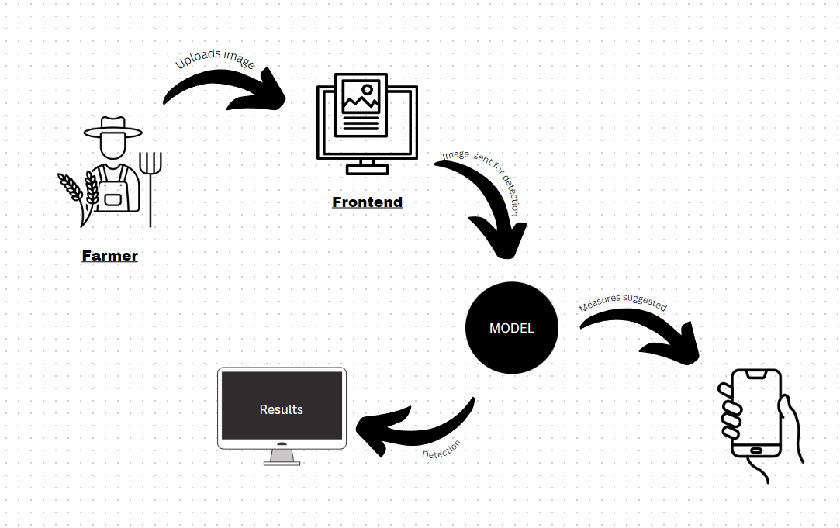

Fig 5.1: Architecture Diagram

Architecture diagram comprises the mapping of the physical components of the application system. In our project, the user could access the UI portal of the web application in which the input files would be stored and processed temporarily to generate the results.

**5.2 Design Details**

**5.2.1 DFD Diagram**

DFD or Data Flow Diagram shows the flow of information in a system.

**i. DFD Level 0**

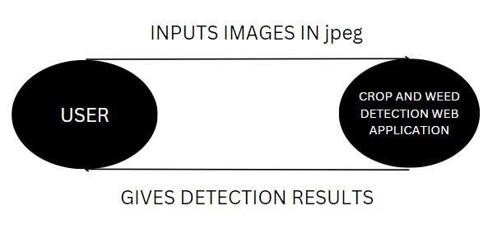

Fig 5.2.1: Data Flow Diagram Level 0

DFD Level 0 or Context Diagram shows the flow of information in the system as a single high-level entity. The user inputs the data to the application and the required results would be displayed to the user.

**ii. DFD Level 1**

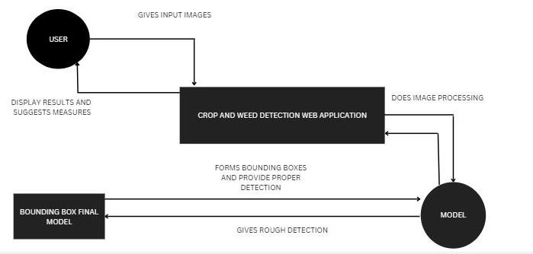

Fig 5.2.1: Data Flow Diagram Level 1

In DFD Level 1, the Context Diagram is decomposed into multiple detailed processes. The data such as audio data, image and the data from the report, is processed with the help of various algorithms. Using this processed data, the model predicts and outputs the results.

**5.2.2 Activity Diagram**

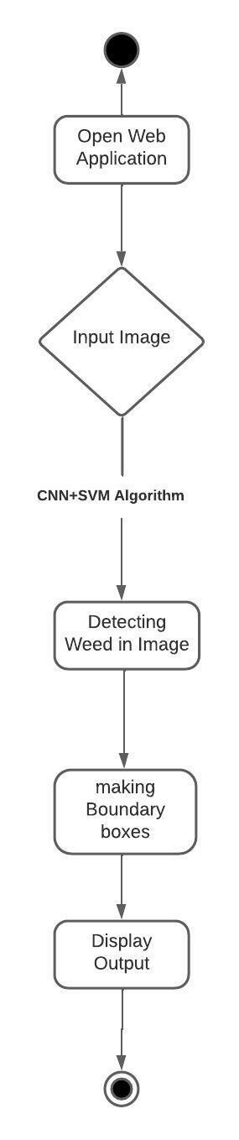

### Fig 5.2.2: Activity Diagram

### Activity Diagram shows the stepwise activities or processes in a graphical form. After landing on the home page, the user is given an option to upload data either in the form of audio, image and report and can input the data in their given respective fields. In either case, this data is sent to the model to give out the results.

**5.2.3 Sequence Diagram**

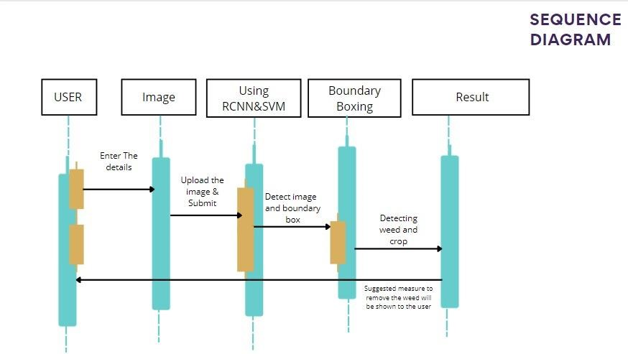

### Fig 5.2.3: Sequence Diagram

Sequence Diagram shows the interactions between entities in a sequential manner. In our system, the user first opens the web application. Input fields would be provided to upload or input the data. The user manually provides data. The application then seeks insights from the data that has been provided. The application then displays the results to the users.

### 5.3 Methodology

### 5.3.1 Data Model

Step1: Downloading Dataset

We Downloaded the dataset from Kaggle. The dataset comprises of 1300 images of crop and weed.

The dataset contains images of sesame crops and weed growing in its nearby area.

Step 2: Data Pre-processing

First we applied selective search algorithm and generated ~2000 region per images.

Then we compared generated region with ground truth labels by mean of Intersection over union(iou).

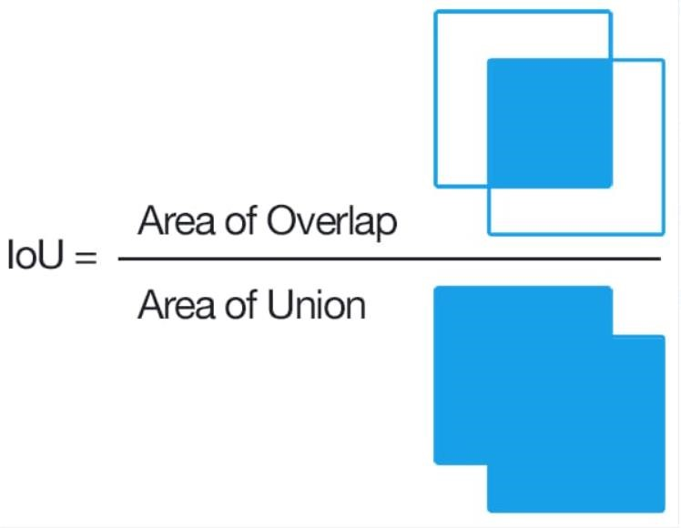

Whichever region has iou>0.5 is saved as positive example(it might object) and region which has iou<0.2 is saved as negative example.

Then we saved the coordinates of bounding boxes and also saved all the images

Step 3: Splitting data into train and test

We divided the dataset into 70-30 ratio i.e. 1000 images for training and 300 images for testing

Step 4: Training of Model

After going through various research papers, we decide to use R-CNN and SVM as it was best suited with the dataset.

Our RCNN Model training is divided in three parts

1.CNN finetuning

2.CNN + SVM training

3.Bounding Box regression

1. CNN finetuning

We finetuned VGG16 model with our generated region proposals.

Input size of model is 224x224x3 and Output 3 classes (Crop, Weed and Background).

Model perform very well and give 95.88% accuracy on test images. We used Jupyter platform to train our models

1. CNN + SVM

We removed last two fully connected layers from finetuned model and used CNN model as feature extractor.

CNN model will return (1,4096) size feature vector.

Then we trained SVM model using feature vectors.

SVM improves overall prediction of model.

3.Bounding Box Regression

With bounding box coordinates we form boxes around the crop/weed and use the image in the boxes for detection.

Step 5: Testing the model

From the test dataset containing 300 images we have tested images for both crop and weed and received good detection accuracy.

Step 6: Saving the model

We saved the trained and tested model in h5 format which will be used for detection when the user enters the values in API or GUI

**CHAPTER 6**

**Experimental Setup**

### 6.1 Requirement Analysis and details about input to systems or selected data.

Operating Systems such as Windows, Linux or MAC can be used, A minimum of 4 to 8 GB RAM is required to process the heavy models. At least 2.8Ghz CPU speed would be required. Visual Studio Code is a code editor redefined and optimized for building and debugging modern web and cloud applications. For running a project in data science or data visualization, one could use Jupyter notebooks inside VS Code. Python is an interpreted, high-level, and general-purpose programming language. The entire GUI and processing in this project will be done in python. In this project, we are going to use python's web-based framework, Flask. Flask's primary goal is to ease the creation of complex websites. CSS is used to style an HTML document. CSS describes how HTML elements should be displayed. Bootstrap is a framework which is used to create user interfaces in web applications. It provides CSS, JS and other tools that help to create the required interfaces. In Flask, we can use bootstrap to create more user-friendly applications. Pickle file is used to save a machine learning model.

After processing the user input data through the model an output is displayed on the webapp through custom template.

### 6.2 Performance Evaluation Parameters (for Validation)

There are different Machine Learning Modules used in the project for the predictive analysis. Different parameters are considered by the machine learning models to give out an accurate prediction.

Different user input(reports) which are required for detecting Crop and Weed are:

* Crop Name
* Area

### 6.3 Software and Hardware Set up

### i. Hardware requirements

* I5 & above processor
* 8 GB RAM
* 10Gb HDD free space
* Windows 10 Operating System

### ii. Software requirements

* Python: Python is one of the widely used programming languages for building systems that indulge in Image Processing as well as Machine Learning. Python provides amazingly powerful libraries and tools that help us in achieving the tasks efficiently.
* OpenCV: It stands for Open-Source Computer Vision Library. This library consists of around 2000+ optimized algorithms that are useful for computer vision and machine learning. There are several ways you can use OpenCV in image processing like Conversion of images, Smoothening of images, etc.
* TensorFlow: provides tutorials, examples, and other resources to speed up model building and create scalable ML solutions. The library is designed to work with a wide range of hardware configurations, including CPUs, GPUs, and TPUs, and it can be used for various tasks such as image and speech recognition, natural language processing, and many others.

* NumPy: This is a library that lets one perform simple image techniques such as flipping images, extracting features and analyzing them. NumPy provides several features that are useful for numerical computing, like ndarray, Mathematical functions for performing operations on arrays, Linear algebra, Fourier transform, and random number generation functions. NumPy is a fundamental package for scientific computing in Python and is often used in conjunction with other scientific computing libraries such as SciPy, Matplotlib, and Pandas. It is widely used in various fields such as physics, astronomy, engineering, finance, and machine learning.
* Pandas: Pandas is an open-source library that is made mainly for working with relational or labelled data both easily and intuitively. Pandas is built on top of NumPy and provides data structures like Series (1-dimensional) and DataFrame (2-dimensional) that are designed to handle tabular data. Pandas is widely used in data science and machine learning for data cleaning, transformation, exploration, and visualization. key features of Pandas is Reading and writing data from a wide range of file formats, such as CSV, Excel, SQL databases, and JSON. Handling missing or incomplete data using methods such as interpolation, filling, and dropping.
* TQDM This library in Python is used to add progress bars that show the processing behind the execution of the program. TQDM is easy to use and provides a simple way to visualize the progress of a loop. It works by wrapping an iterable object with a progress bar that updates as the loop progresses. The progress bar displays the current iteration, the percentage of completion, and an estimated time remaining for the loop to finish.

**CHAPTER 7**

**Result**

The UI of this application is designed in such a way that it gives ease of use to any user. When one opens the application, he or she has access to two tabs. One is the homepage which provides a general overview of agriculture and Artificial Intelligence. The next tab is used by the user to upload image ad fill necessary data.



Fig 7.1.1 Homepage

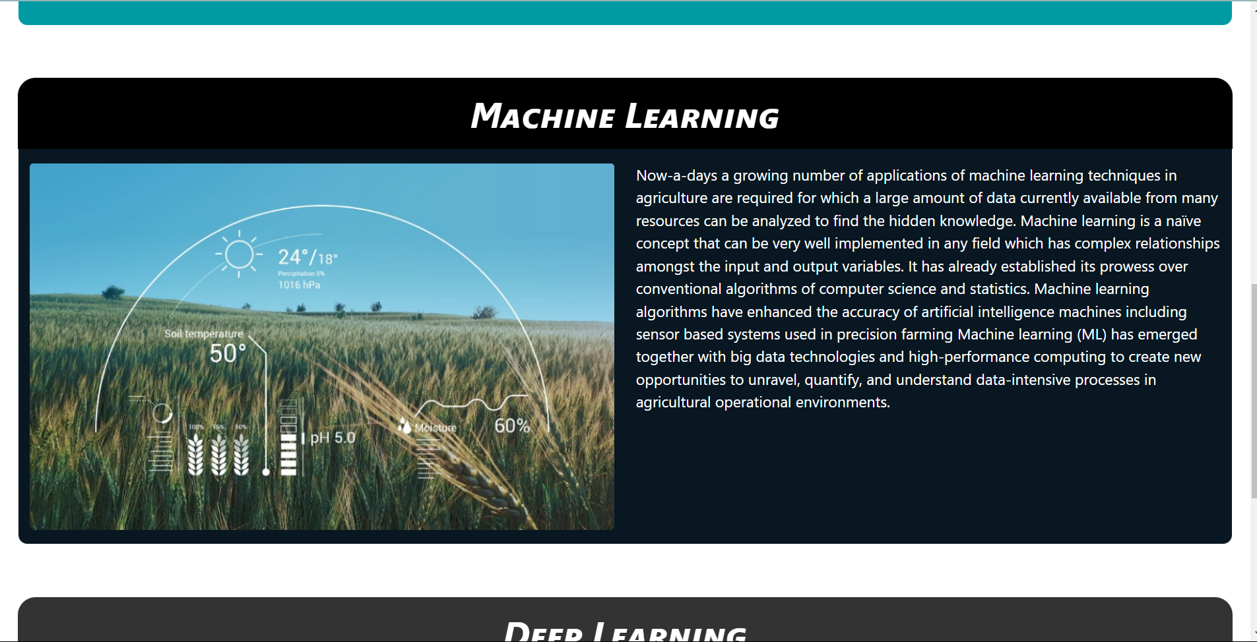

Fig 7.1.2 Homepage

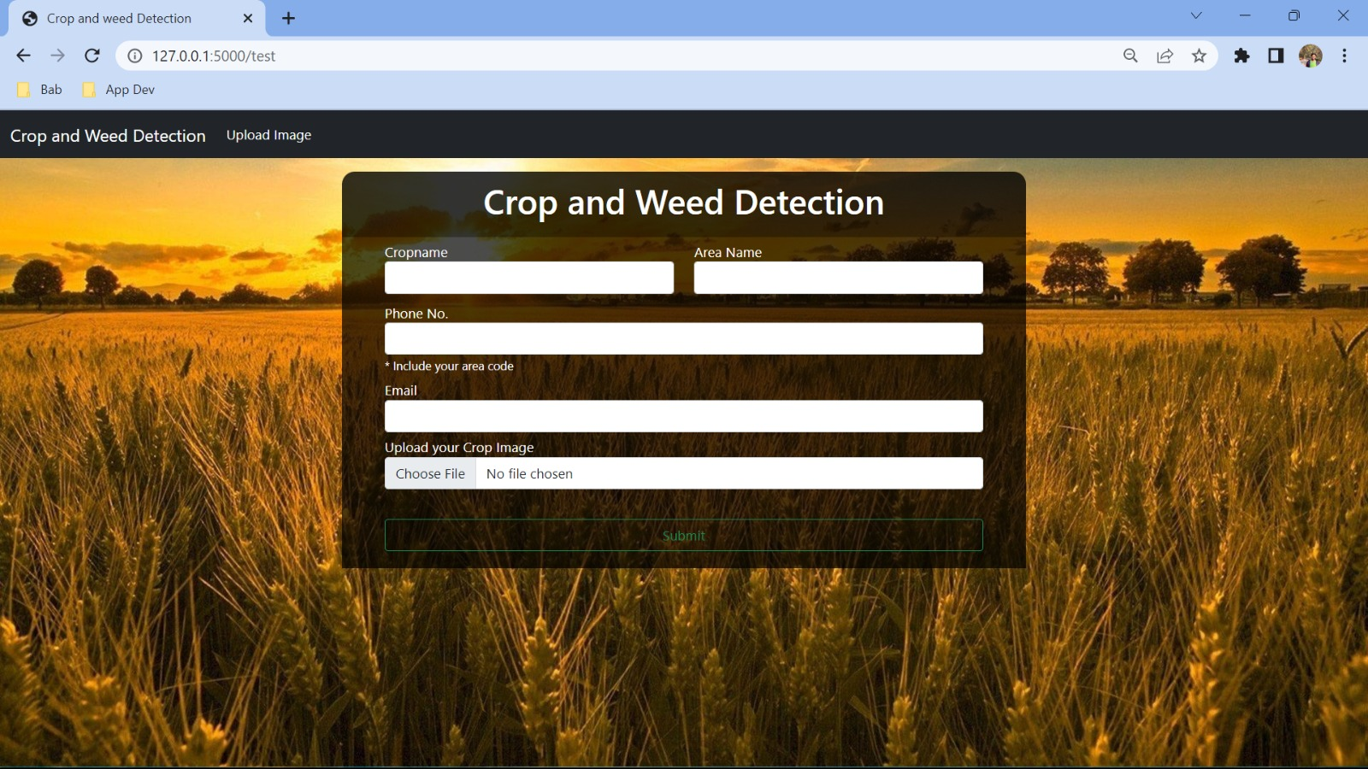

Fig 7.2 Upload Tab

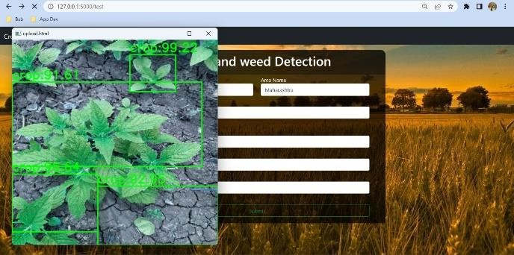

Fig 7.3.1 Crop Detection with Multiple Bounding Boxes

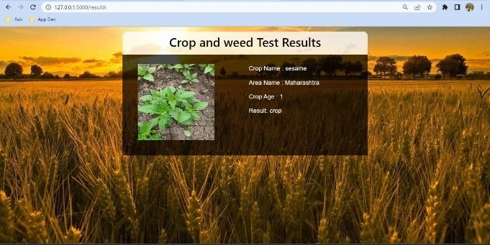

Fig 7.3.2 Crop Detection Results

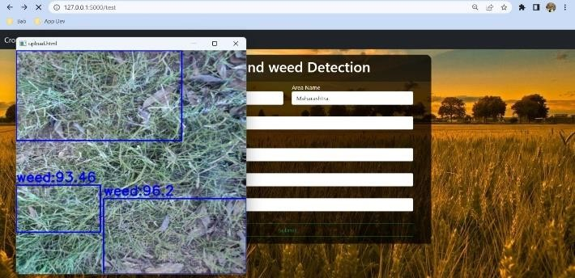

Fig 7.4.1. Weed detection with Multiple Bounding Boxes

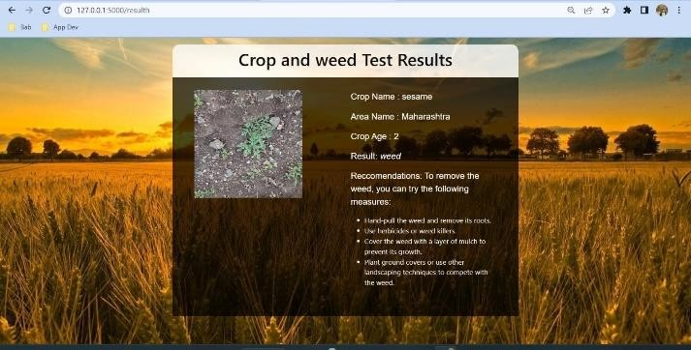

Fig 7.4.2 Weed Detection Results



Fig 7.5. Measures to Remove Weed suggested by Text Message

**CHAPTER 8**

**Project Plan**

Our project started in July 2022, and after finalizing the topic and objectives, we began working on it. Phase one covered project conception, project study, and design layout. In phase two, we designed our proposed system, and in the final third phase, we completed project implementation, and submitted a research paper along with our results.

**Gantt Chart**

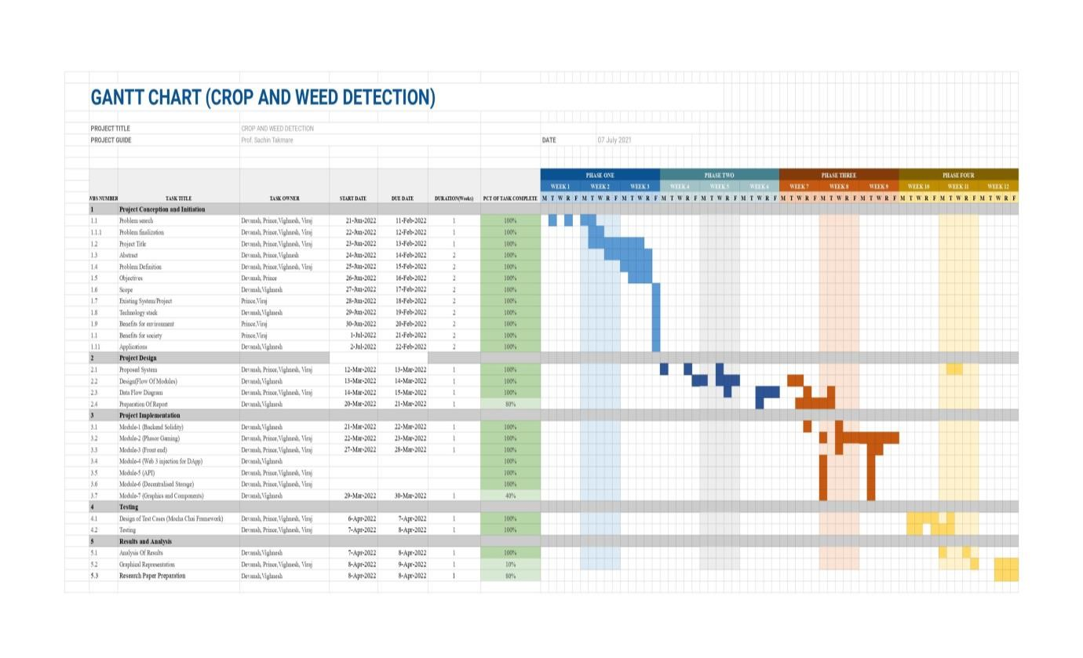

**CHAPTER 9**

**Conclusion**

In conclusion, being able to predict the status of crop and weed. The proposed method can be applied not only to the data set, but also to the type of weed. Combining ground truth images and constructing multiple convolutional neural networks for identification and comparison, the only regret is that crops and weeds in the picture are infected to some extent, and the recognition accuracy needs to be improved. Early weed detection is crucial in agricultural productivity, as weeds act as a pest to crops. This work aimed to detect weeds in a chilli field using image processing and machine learning techniques. The UAV images were collected from an Australian chili farm, and these images were pre-processed using image processing techniques. Then features were extracted from the images to distinguish properties of weeds and the crop. Three different classifiers were tested using those properties: RF, SVM, and KNN. The experimental results demonstrate that RF performed better than the other classifiers in terms of accuracy and other performance metrics. RF and SVM offered 96% and 94% accuracy in weed detection from RGB images, respectively, whereas KNN offered only 63% accuracy. In the future, we will explore multispectral and hyperspectral UAV images, and will apply deep learning algorithms to increase the accuracy of weed detection.

**CHAPTER 10**

**Future Scope**

The future scope for weed management is significant, as it is an essential component of sustainable agriculture and environmental conservation. Some potential areas of research and development in weed management include:

1. Advancements in weed identification and mapping technologies, such as remote sensing and machine learning, to enable rapid and accurate identification of weed species and their distribution patterns.
2. The development of new herbicides and alternative weed management strategies, such as bioherbicides, allelopathic compounds, and precision cultivation practices.
3. The optimization of precision agriculture technologies, such as robotic weeders and sensors, to improve their effectiveness and cost-effectiveness in weed management.
4. Research on the impacts of climate change on weed populations and their interactions with crop plants, as well as the potential for weeds to become invasive in new regions.
5. The development of integrated weed management approaches that incorporate a combination of cultural, mechanical, and chemical methods, as well as biological control and restoration ecology.
6. Overall, the future of weed management will require a multidisciplinary approach that incorporates advances in technology, ecology, and agronomy, as well as collaboration among researchers, farmers, policymakers, and the public.

### Bottom of Form

**References**

1. Tang J, Wang D, Zhang Z, He L, Xin J, Xu Y. Weed identification based on K means feature learning combined with convolutional neural network. Comput Electron Agric. 2017;135:63–70.
2. Ahmed F, Al-Mamun HA, Bari AH, Hossain E, Kwan P. Classification of crops and weeds from digital images: a support vector machine approach. Crop Prot. 2012;40:98–104..
3. Kunz C, Weber J, Peteinatos G, Sokefeld M, Gerhards R. Camera steered mechanical weed control in sugar beet, maize and soybean. Precis Agric. 2018;19(4):708–20.
4. Tang JL, Chen XQ, Miao RH, Wang D. Weed detection using image processing under different illumination for site-specific areas spraying. Comput Electron Agric. 2016;122:103–11..
5. D.S. Radhika Shetty and G.K. Roopa, “Weed Detection using Image Filtering in Vegetables Crops”, IOSR Journal of Computer Engineering, Vol. 21, No. 1, pp. 61-64, 2019.
6. Pejman Rasti, Ali Ahmad, Salma Samiei, Etienne Belin and David Rousseau, “Supervised Image Classification by Scattering Transform with Application to Weed Detection in Culture Crops of High Density”, Remote Sensing Journal, Vol. 11, No. 249, pp. 1-16, 2019.
7. Adel Bakhshipoura and Abdolabbas Jafarib, “Evaluation of Support Vector Machine and Artificial Neural Networks in Weed Detection using Shape Features”, Computers and Electronics in Agriculture, Vol. 145, pp.153-160, 2018.
8. B. Cheng and E. T. Matson, “A feature-based machine learning agent for automatic rice and weed discrimination.” in ICAISC (1), 2015, pp. 517–527.
9. Saleem, M.H.; Velayudhan, K.K.; Potgieter, J.; Arif, K.M. Weed Identification by Single-Stage and Two-Stage Neural Networks: A Study on the Impact of Image Resizers and Weights Optimization Algorithms. Front. Plant Sci. 2022, 13, 920
10. Girshick, R., Donahue, J., Darrell, T., Malik, J. (2014). Rich feature hierarchies for accurate object detection and 17 semantic segmentation. In Proceedings of the IEEE Conference on Computer Vision and Pattern Recognition, pp. 580-587.
11. Haug, S., Ostermann, J. (2015). “A Crop/Weed field image dataset for the evaluation of computer vision based precision agriculture tasks,” in Computer vision - ECCV 2014 workshops lecture notes in computer science. Eds. Agapito, L., Bronstein, M. M., Rother, C. (Cham, Switzerland:Springer International Publishing), 105–116. doi: 10.1007/978-3-319-16220-1_8
12. Chen, Y., Li, W., Sakaridis, C., Dai, D., Van Gool, L. (2018). Domain adaptive faster R-CNN for object detection in the wild. In Proceedings of the IEEE Conference on Computer Vision and Pattern Recognition, pp. 3339-3348
13. S. H. Hlaing and A. S. Khaing,“Weed&crop segmentation and classification using area thresholding,” IJRET, vol. 3, pp. 375–382, 2014.
14. S. Ren, K. He, R. Girshick, and J. Sun. Faster r-cnn: Towards real-time object detection with region proposal networks, 2015.
15. Kazmi W, Garcia-Ruiz FJ, Nielsen J, Rasmussen J, Andersen HJ. Exploiting affine invariant regions and leaf edge shapes for weed detection. Comput Electron Agric. 2015;118:290–99.
16. Dos Santos Ferreira, A., Freitas, D. M., da Silva, G. G., Pistori, H., & Folhes, M. T. (2017). Weed detection in soybean crops using ConvNets. Computers and Electronics In Agriculture, 143, 314-324.
17. Yao, Q., Guan, Z., Zhou, Y., Tang, J., Hu, Y., & Yang,B. (2009, May). Application of support vector machine for detecting rice diseases using shape and color texture features. In Engineering Computation, 2009. ICEC'09. International Conference on (pp. 79-83). IEEE.
18. Open Data Science, ‘Overview of the YOLO Object Detection Algorithm’, 2018. [Online]. Available:https://medium.com/@ODSC/overview-of-the-yolo-object-detection-algorithm7b52a745d3e0.
19. Semantic Scholar,’Precise Weed and Maize Classification through Convolutional Neural Network’,2020.
20. Bhanumathi G, Subhakar B. Smart herbicide sprayer robot for agriculture fields. International Journal of Computer Science and Mobile Computing. 2015; 4(7):571–4

**Publications**

**Paper 1: CROP & WEED DETECTION USING RCNN & SVM**

Conferences:

[1] ICCIXAI -2023, Conference on “Computational Intelligence and XAI

Status: Paper Accepted